

|  |
| --- |
| MTN.BI.07 Introduction to Data Warehousing  Introduction to Data Warehousing |
| Laboratory work |

Contents

1. Virtual machine setting 3

2. GIT 4

# 1. Virtual machine setting

1. VM “BI 2018.ova” was imported.

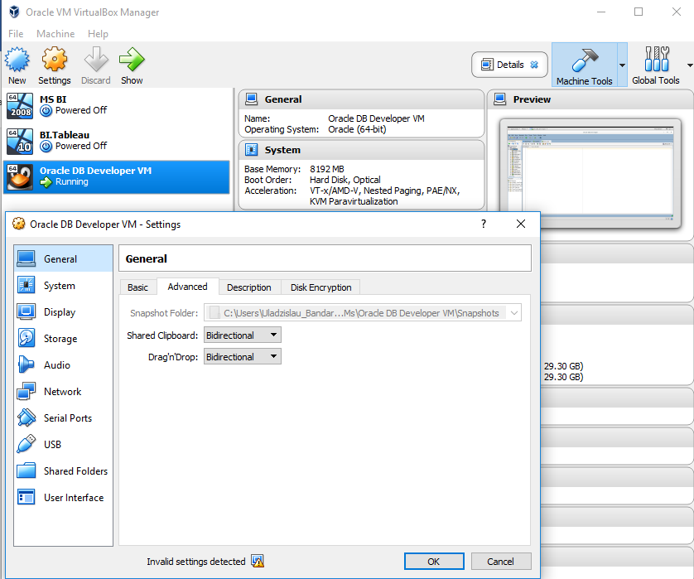

1. Set shared folder between your windows machine and remote machine (this folder might be your GIT folder)

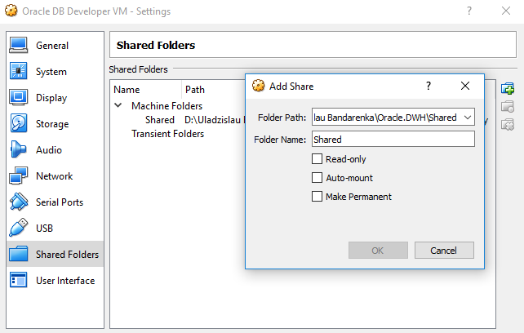

1. Connect to Oracle using sqldeveloper from your Windows machine (port forwarding in your virtual machine needs to be enabled)

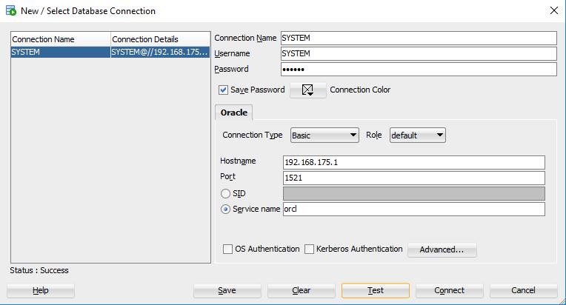

1. Creating user (in Oracle) test_user.

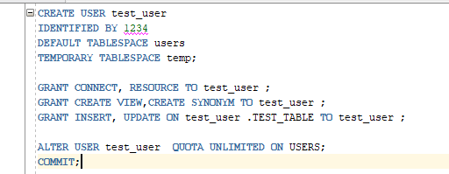

Creating schema (in Oracle) test_user.

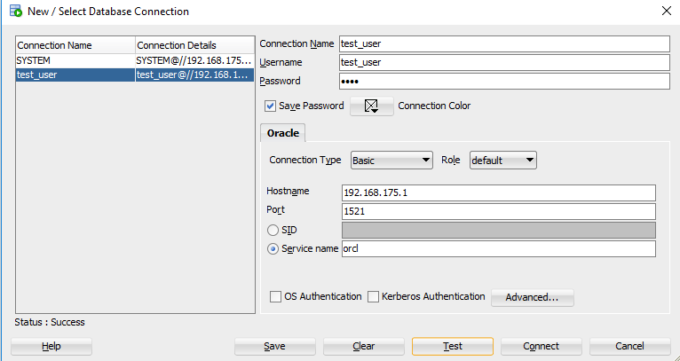

# 2. GIT

1. Pass GIT tutorial <https://githowto.com/>
2. Clone our “BI_Lab_winter-spring_2018” repository

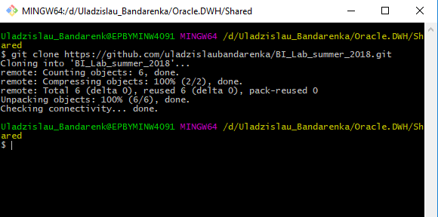

1. Add, commit and pull your personal folders to “BI_Lab_winter-spring_2018\_0. DWH\Project\” and “BI_Lab_winter-spring_2018\_1. Introduction to DWH\Tasks”, use “Name_Surname” template.

Creating branch, adding, commit personal folders. 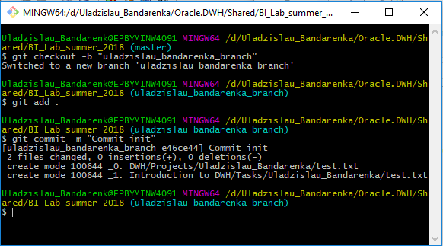

Pushing personal folders.

